Weekly Learning Plan for ENSH2 Shakespeare in blended mode
Module convenor | Lauren McCann / Emma Herrod
Other key contributors | Chris Johnson, Jackie Fairbairn, Daniel Barker
Week commencing | Week 1 – w/c 28 September 2020
How this week relates to your module learning outcomes | During this week, we’ll focus mainly on LO1 (to understand Hamlet’s distrust of women) with a focus on Act One of the play, looking for examples and discussing where his distrust is rooted.
Topics/themes covered this week | Hamlet – Hamlet’s distrust of women
Core lecture content |  | Three mini-lecture screencasts to access in Blackboard (Week 1) prior to the interactive session, covering the following:  1. An introduction and overview of Hamlet  2. Hamlet and women (part 1)  3. Hamlet and women (part 2)  Each has a question to consider whilst watching. These will be used as a basis for discussion during the interactive session.
Scheduled live interactive sessions |  | Online: Thursday 1 October, 10-11am BST (using Blackboard Collaborate – session link)  Face-to-face (socially distanced): Thursday 1 October, 3-4pm BST (Carrington 2.01)  Small group discussion based on lecture screencast questions.
Activities, tasks and discussion | 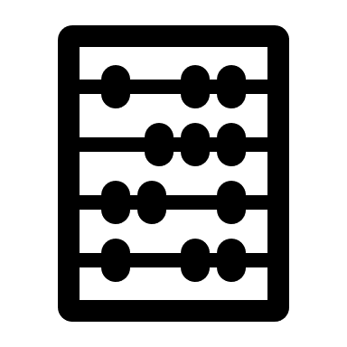 | Prior to the interactive session:  Watch lecture screencasts & consider questions.  Blackboard Quiz based on lecture screencasts – 5 questions  Contribute to the Discussion Forum about the role of women in Hamlet.  Following the interactive session:  Capture your ideas following ideas generated during the group discussion – these will help with your reflective journal assessment.
Labs/practical sessions |  | N/A
Studio sessions |  | N/A
Field trips |  | N/A
Independent study |  | Essential reading: Chapter X of xxxx – see TALIS reading list.  Explore the additional curated resources within the Blackboard module (Additional Resources folder).
Formative/Summative  Assessment |  | Blackboard Quiz (MCQ) – to informally assess knowledge and understanding based on this week’s lecture screencasts.  NB Discussions during interactive session will lay the groundwork for reflective journal assessment.

