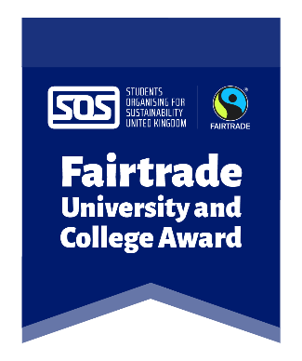
Become a student auditor for the Fairtrade University & College Award!
Voluntary role, approx. 8 hours total, including:
- A free training session delivered by SOS-UK and the Fairtrade Foundation, via Zoom
- A remote/in-person audit at your university or college
- Earn volunteering hours towards your RED Award

The Fairtrade University & College Award
This Award gives recognition to institutions that have embedded Fairtrade and some wider sustainable practices through their curriculum, procurement, research and campaigns. We know many students care about Fairtrade and sustainability already and the Award gives universities and colleges an opportunity to demonstrate their progress as well as improve further.
In order to achieve the Award, a remote/in-person student-led audit will be conducted at each university and college to verify their level of achievement.
The role of a student auditor
Student auditors will work in groups of two to four to audit all aspects of their own university or college’s work on the Fairtrade Award. You will firstly be fully trained on the award criteria and how to conduct an audit by SOS-UK and the Fairtrade Foundation in a training session conducted over Zoom. You will then review documents submitted by your institution and then meet with their staff (either in-person or online) to discuss their submission and any queries.
The Award staff team will be on hand to provide support to auditors and moderate as needed.
Desirable Qualities
No technical knowledge is needed as full training will be provided. However, there are a few desirable qualities that a student auditor would already have:
- A passion for ethical purchasing
- An interest in social and environmental issues
- Confident speaking to new people, and working within a team
- Competent with use of Microsoft Excel
- Ability to act in a professional manner
Skills you will gain:
- Leadership
- Communication
- Presentation skills and public speaking
- Time management
- Problem solving
You will also have the opportunity to meet like-minded students and learn more about Fairtrade, trade justice and ethical consumption.
How do I get involved?
Register your interest by filling out our short application form online on or before Wednesday 10th April 2025:
Fairtrade auditor application form
We are looking for 5 student auditors. We will be in touch with the chosen applicants by 11th April 2025 with details of the training session and the next steps.

