This article is a general guide to adding pre-formatted tables from word to Blackboard Portfolio.
This article is especially relevant to the Pharmacy Portfolio and uses examples of their tables and portfolio template.
There are templates for tables in the supporting materials. They have instructions as to how to complete the tables.
These are best completed in the word document, but can be added to and edited comparatively within the Blackboard text editor.
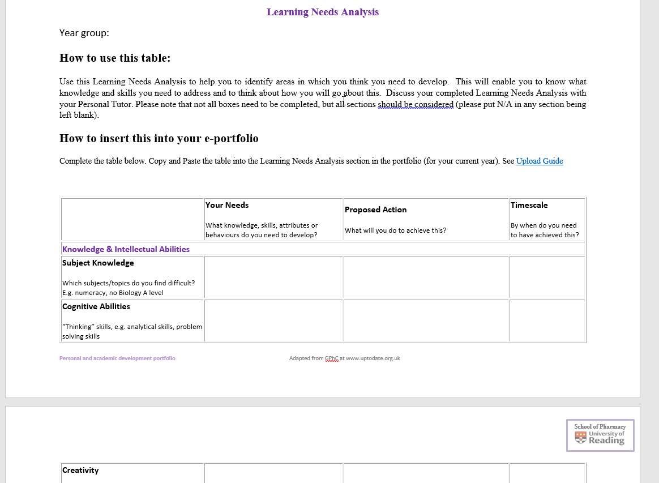

Copying the table
Select the highlight table button

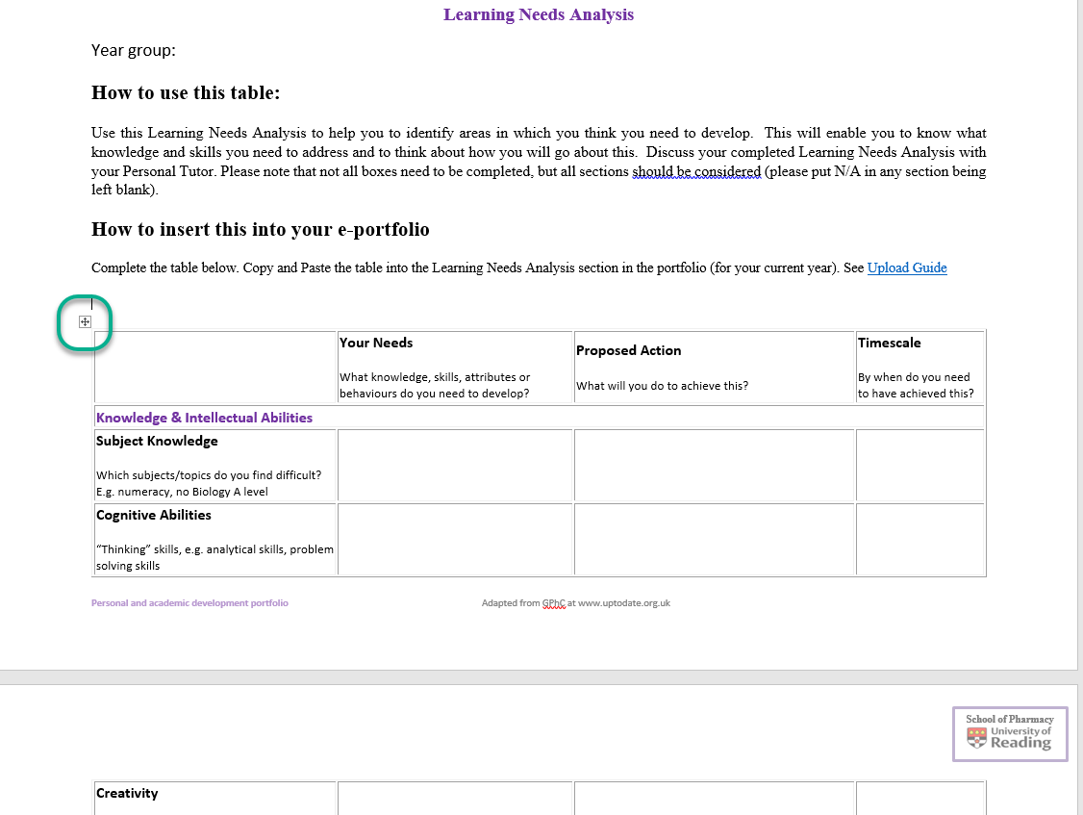

When the table is highlighted use CTRL + C to copy.

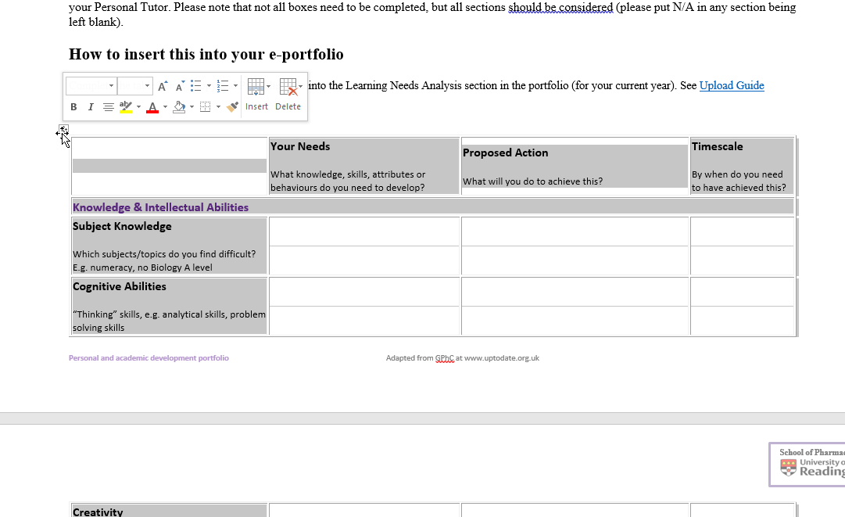
Paste into Blackboard
Open your Portfolio, Select Edit
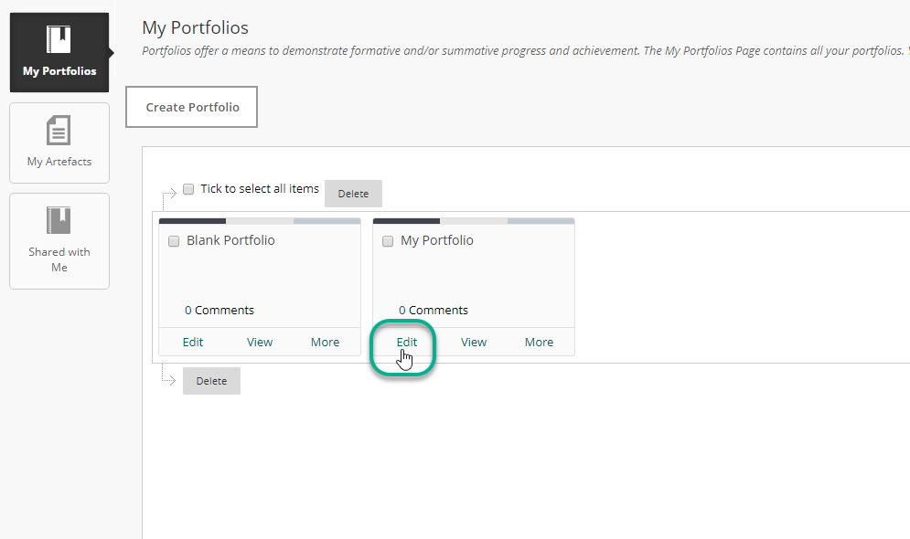
Select the area you want to paste the table into.
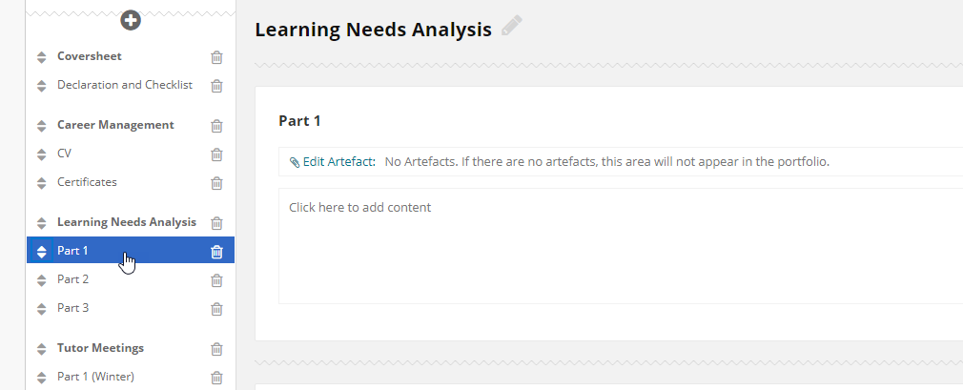
Click into the area which states ‘click here to add content’

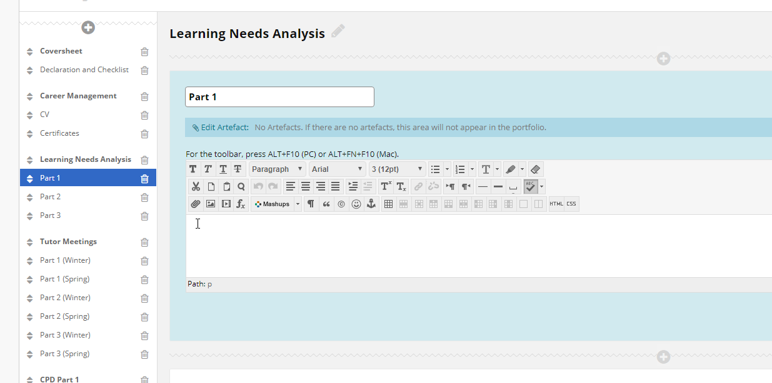
Use CTRL + V to paste.
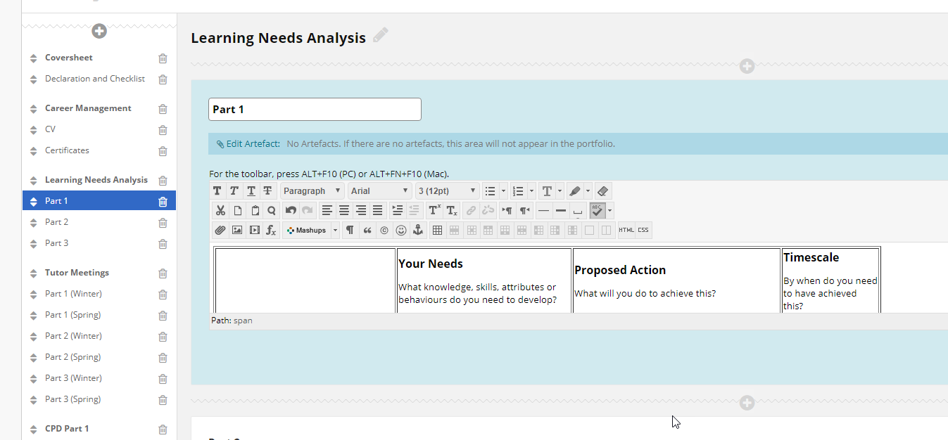
The table will copy into the box in the same format as in word.
Use the expand box button to see a larger view
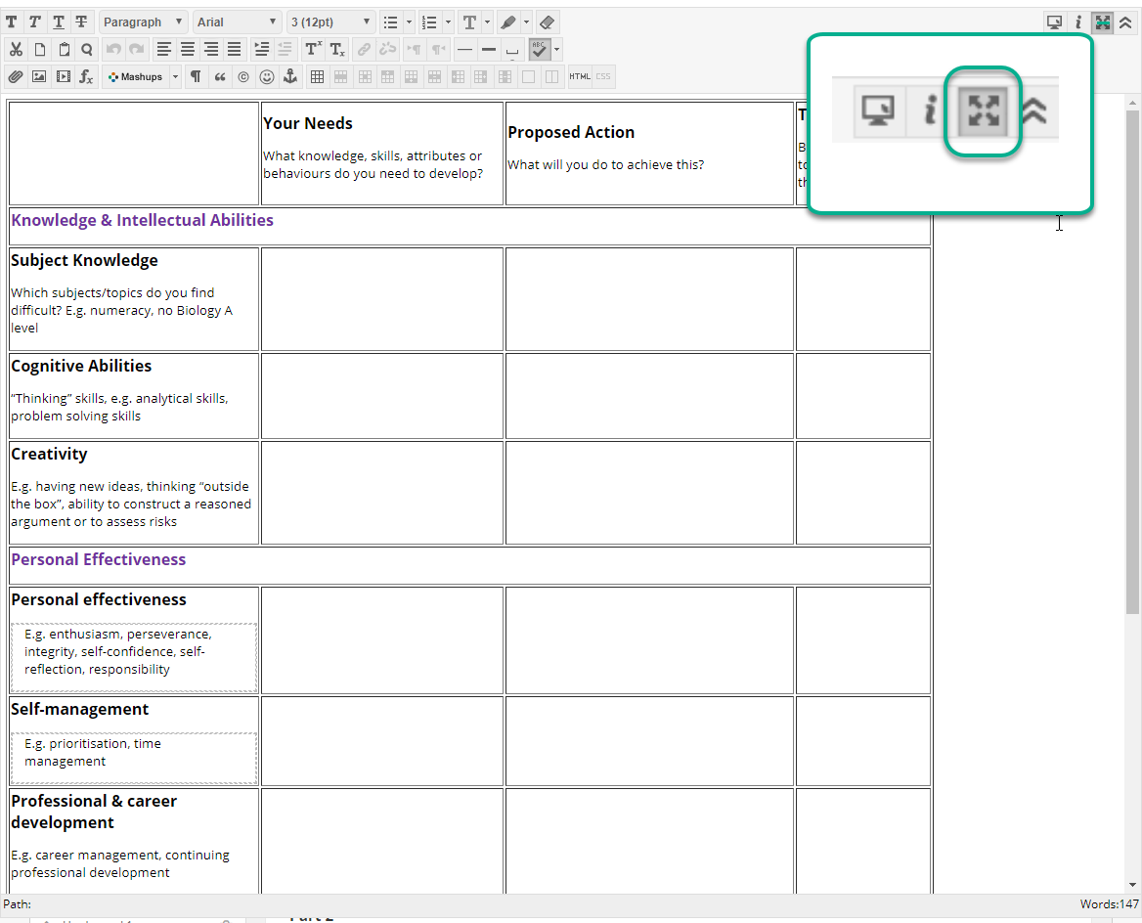
Always click Save to make sure you don’t loose your work.
