Recommended settings for Take Home Exam submission points

General principles

For the Take Home Exam content area in Blackboard courses
- A Take Home Exams content area will be created in each Blackboard course having an exam. | This provides a clearly defined space for students that is easy to find and consistent across all modules.
- These content areas will be available to students immediately upon creation.

- These content areas will contain general exams advice – pulled in from one or more Reusable Objects, so can be updated centrally as required. | This will be kept short by linking to central advice on Essentials, including support and technical guidance.
- Programme Admin can also use this area to provide separate advice for specific exams – e.g. equipment students will need, whether exams will need to be word processed or handwritten and scanned.

- Inside the Take Home Exams content area, Programme admins should create a separate folder for each Exam. | This provides distinct discrete areas for each exam that can be time released and students can easily identify.
- This folder must be set:  - To become available (Display After) on 10 am on the day of the exam.  - To become unavailable (Display Until) 9 am on the day following the exam. | Implication: students must have started to submit before the deadline, otherwise they won’t be able to access the submission point – there will be no late submissions for these exams.

Turnitin and Blackboard principles for settings
- Turnitin should be used wherever practically possible for take home exam submissions.  The exceptions are if it is an MCQ Test or the exam needs to be entirely handwritten. | Turnitin can be used where elements of the exam need to be hand drawn or written e.g. diagrams, notation and equations.  Students can take pictures of these elements with their phones and insert them into a Word document alongside typed answers.  Note: Turnitin requires submissions to have at least 20 words of typed text to allow it to be submitted.
- A Blackboard Assignment needs to be used for exams that need to be entirely handwritten and students are submitting a scanned image file.
- A Blackboard Test needs to be used if the exam is made up predominantly of MCQ type questions and occasional short answer questions.

- If appropriate, you can create a separate submission point for each section of the exam.  e.g. if there are 3 essay questions, you could create a separate Turnitin assignment for each.  This might equate to each section of the exam, which would require a separate answer book in a physical exam.  Separate submission points may be required where different submission tools are needed for each part of the exam e.g. section 1 works best as a Blackboard Test, section 2 works best as a Turnitin assignment. | Set up separate submission points where appropriate – Module Convenors should discuss this with their Senior Programme Administrator.  Allows for work to be submitted as it is completed by the student.  Allows different questions or sections of an exam to be marked by different markers simultaneously.  Implication: Increases the possibility of students submitting to the answer to the wrong submission point.
- Unlimited submissions | Allows contingency for student access and technical issues.
- Submission points available for 23 hours | Allows contingency for student access and technical issues.
- Use a standard naming format for exams in Turnitin Assignment Title / Blackboard Assignment Name field. | A standard format for naming is required e.g. Module code - exam name - question number  AB1THE - Exam 1 - Question 1  A standard format will make it easier to locate your papers in the Grade centre and when marking esp. where there is more than one exam and more than one submission per exam
- Instructions (Turnitin) or Description (Bb Assignment) text box: only enter necessary information.
Avoid duplicating instructions provided elsewhere in the Take Home Exams area.

Turnitin
Turnitin will be used wherever possible for submission of Take Home Exams.
The following default settings are recommended.
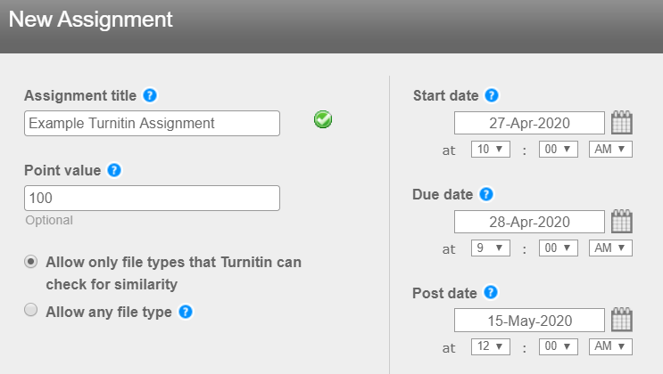
- Point value = 100 | Marking out of 100 allows for a percentage mark to be given.  Weighting for multiple answers submitted in separate submission points can be set in the Grade Centre to make a combined overall total mark for the exam.
- Choose Allow only file types that Turnitin can check for similarity  Exception: where papers will consist predominantly inserted images use ‘Allow any file type’ | We are generally recommending Blackboard assignments for exams that require students to submit entirely scanned handwritten work. But there may be exceptions.  ‘Allow any file type’ ensures files with less than 20 readable words of text can be submitted.
- Start Date = No need to set this  (to set the date and time when the exam opens i.e. 10 am on the day of the exam.) | Since the Turnitin assignments will be inside a folder which is itself date-protected, and students won’t have access to the exam questions before hand, means it isn’t essential for access control and could be skipped to save time.
- Due date = date and time when exam close i.e. 9 am on the day after the exam. | MUST DO  Set this date and time as it is seen by students when submitting their work.
- Post date = date when anonymity should be lifted. | Marking is anonymous, but anonymity is lifted before moderation, and moderation is not done anonymously.  Reason: anonymous marking is technically difficult to administer, especially for large cohorts.  TEL recommends that anonymity should be lifted before moderation begins to make this process manageable for the moderators. Anonymous moderation is complex to administer and organise.  The post date needs to align with the marking deadline that has been agreed between the markers and the PAs.  Use the marking deadline as the initial post date.  The post date can be edited at any time to extend the date and maintain preserve anonymity but cannot be re-applied once the date has been reached and anonymity is lifted.  The post date also dictates when marks are transferred to the Grade Centre from the Turnitin Inbox.  Implication and assumption: The column in the Grade Centre for the exam needs to be hidden to prevent students seeing their mark and accessing their paper. Marks should only be released in RISIS.
- Allow submissions after the due date?  Leave on default setting | Irrelevant as students can’t access the assignment after the due date
- Generate Similarity Reports for submissions? Yes (as appropriate for the exam questions) | Yes is selected where a similarity report is appropriate.
- Generate Similarity Reports for student submission On due date | This setting allows for students to resubmit their paper and provides a contingency for any access and technical issues
- Allow students to see Similarity Reports? No | Students do not need to see a similarity report for an exam to prevent them editing and resubmitting work based on the similarity score and creating additional student anxiety.
- Reveal grades to students only on post date? No | Setting this to No ensures the Grade Centre column is not revealed to students when the post date is reached.
- Enable anonymous marking? Yes | MUST DO  This reflects the way paper-based exams are currently marked.
- Submit papers to: Standard paper repository (and keep all Search options ticked)
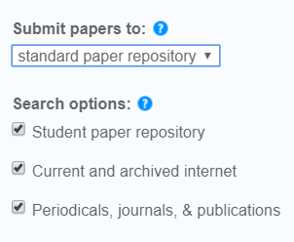
- Attach a Turnitin Rubric or Grading Form, if appropriate, e.g. if being used to assign marks to specific questions. | Please agree with the Module Convenor exactly what is required.
In the Grade Centre

- IMPORTANT: when you have created your Turnitin assignments, you need to go the Grade Centre and Hide column from students.
This should ensure that if you go to ‘Edit Column Information’ the settings are as shown below:
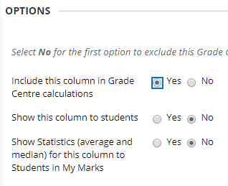
- Include this column in Grade Centre calculations = Yes | So that you can include the assignment in the [IC] Weighted Total column for the Exam
- Show this column to students = No | To ensure students will not be able to view their marks in My Marks.

Blackboard assignments
- Due date = date and time when exam close i.e. 9 am on the day after the exam.

- Points possible = 100

- Attach Rubric if appropriate e.g. if being used to assign marks to specific questions.

- Submission details

- Assignment Type Individual

- Number of attempts Unlimited

- Marking Options

- Enable Anonymous Marking Yes

- Disable Anonymous Marking  Choose a date when all first marking will have finished.  Anonymity should be removed before moderation begins.  This date can be moved forward or back as required. | Marking is anonymous, anonymity is lifted before moderation and moderation is not done anonymously.  Reason: anonymous marking is technically very difficult to administer, especially for large cohorts.  TEL recommends that anonymity should be lifted before moderation begins to make this process manageable for the moderators. Anonymous moderation is complex to administer and organise.  The Disable Anonymous Marking date needs to align with the marking deadline that has been agreed between the markers and the PAs.  Use the marking deadline as the initial date.  This date can be edited at any time to extend the date and maintain preserve anonymity but cannot be re-applied once the date has been reached and anonymity is lifted.
- Display of Marks

- Include in Grade Centre marking calculations Yes | So that the assignment marks can be included in the [IC] column for the exam  (Grade Centre Column created by the EMA Integration).
- Show to students in My Marks No | So that students are not able to see the marks in My Marks.  The column in the Grade Centre for the exam needs to be hidden to prevent students seeing their mark and accessing their paper. Marks should only be released in RISIS.
- Availability

- Make the Assignment Available Yes

- Limit Availability  - Display After = Not necessary to set this  - Display Until = date and time when exam close i.e. 9 am on the day after the exam. | Since the assignments will be inside a folder which is itself date-protected, and students won’t have access to the exam questions before hand, this isn’t required – can be left blank to save time.

Blackboard Tests

General principles for Test settings:
When copying and pasting questions from Word use the erase formatting option, to avoid inconsistent font formatting.
Academics are responsible for test content and ensuring that tests are set up correctly.
Academics should liaise with their Senior Programme Administrator in good time before the exam date to clarify roles or arrange additional support if needed.

Settings applied in the ‘Test Canvas’
- When creating the test via the Control Panel, or subsequently by choosing Edit test.

- Instructions
Provide clear instructions on what the students are required to do.

- Random ordering of questions  ‘Specify random ordering of answers’: This is optional. | Randomising the order of answers could act as a safeguard for avoiding collusion. The ability to do this is set when the test is created (tick the box under ‘Questions Settings’ in the Test Canvas to allow this).  Random ordering of answers needs to be applied to individual questions - it can’t be automatically applied to all questions in a Test.  There may be some questions where the answers have to be in a specific order.

Settings when deploying a test
When setting up a Test in the Take Home Exams folder, apply the following options:
- Open the test in a new window = No | Opening in a new window can cause technical issues.
- Show Instructions to students before they begin the test = Yes

- Make available to students = Yes | Visibility dates are controlled by settings further down the screen.
- Add a new announcement for this test = No

- Multiple Attempts = No | MUST DO  Reduces the opportunity for cheating.  Only a single attempt is allowed but students have the ability to re-enter the test to complete it if Internet connection is lost, where Force Completion and Auto-Submit are not enabled.
- Allow Unlimited Attempts = not relevant when multiple attempts is set as no.

- Force Completion = No | MUST DO  Choose this to avoid students being unable to continue a test due to technical issues
- Set Timer = Yes (where appropriate and required)  If a timer is set, set a realistic amount of time for completion of the test. | Set the timer to limit students’ ability to cheat.
- Auto-Submit = Off | MUST DO  This is crucial to avoid technical problems. Auto-Submit only appears if Timer is set.  Implication: students can continue to answer questions but these will be highlighted to the marker as having being completed after the set time.
- Display After = Not required | Since the test will be inside a folder which is itself date-protected, and students won’t have access to the exam questions before hand, this isn’t required – can be skipped to save time.
- Display Until = date and time when exam close i.e. 9 am on the day after the exam.

- TEST AVAILABILITY EXCEPTIONS  When a Timer is set, apply Exceptions for students who need extra time. | TEL will create a guide on this feature – in the meanwhile please refer to Blackboard guide.  Rest breaks: students entitled to rest breaks during exams should be allowed sufficient additional time on the test to take these breaks, based upon the length of the exam.
- Due date = date and time when exam close i.e. 9 am on the day after the exam. | Add this as it displays to students e.g. in the course Calendar and mobile app.
- SHOW TEST RESULTS AND FEEDBACK TO STUDENTS  Untick everything in the first row for When: After Submission.  - Score per question  - Answers  - All answers  - Correct  - Submitted  - Feedback  - Show incorrect questions | As students will be taking the exam at different times, and can make a new attempt, do not show any results to students.
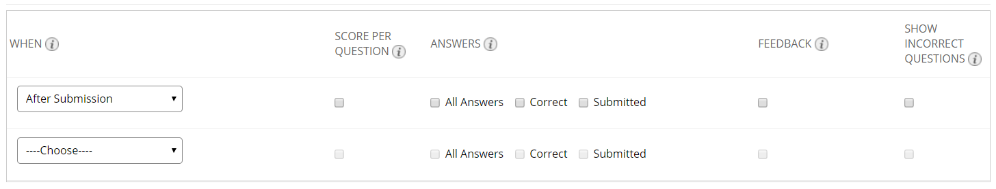
- Test Presentation
Choose how test questions should be presented to the students

- All at once – this is the preferred setting, unless there is a pedagogical reason to choose One at a Time.

- Randomise Questions = Optional; use if appropriate

- In Grade Centre
Ensure the Grade Centre column for the Test is hidden from students.

