14th January 2020

Dear easitMEMBER,

I am writing to thank you for your support for the easitNETWORK scheme. Your participation is not just about discounted travel for your employees; it also plays an important part in reducing traffic congestion, improving local air quality and saving approximately 24,000 tonnes of carbon being emitted each year just in the Oxfordshire and Thames Valley region alone.

We are therefore disappointed to have to tell you that Great Western Railway has told us that it will no longer support the scheme from the end of March this year. We have tried hard to persuade the company to change its mind both because of the impact on cardholders, including your staff, and the effect on the environment, but so far GWR is insisting that it will go ahead with ending our relationship.

Nothing will change straight away. The company has agreed that it will honour discounts on any tickets and season tickets bought before 31 March 2020 by holders of a valid easit card. Users can therefore buy a new ticket up until that date subject to an important caveat: their employer must continue to be part of the scheme for the time the ticket is valid. That means we will continue to run the scheme for corporate partners (including you) until March 2021.

We will of course continue to offer all of our other initiatives, including:-

- South Western Railway 15% discount on journeys to and returning from selected destination stations including Reading, Farnborough, Basingstoke & Wokingham
- Discounts with Halfords, Brompton Bike Hire
- Free access to easiSHARE (your easit journey sharing portal)
- Purchase of On-line Rail Season and Daily Tickets
- Car Club discounts

We have written directly to your employees who are members of the scheme to give them this information.

As I have said we are very disappointed with this decision, but we continue to hope that GWR will change its position before time runs out at the end of March. If you want to join us in pressing the company for a different approach please do let me know; we can update you on what we’ve done
so far and provide relevant contact details and so on.

Alternatively, if you want to express your opinion an easy way to do so is on Twitter. Contact the company via @GWRHelp; it would be helpful if you use the hashtag #easitdiscounts. You may want also to copy in the relevant MP for your destination: @theresa_may (Maidenhead), @LaylaMoran and @AnnelieseDodds (Oxford), @AlokSharma_RDG and @MattRodda (Reading), and @johnredwood (Wokingham).

If you have any questions please do not hesitate to contact me directly.

Thank you again for your support for the easitNETWORK scheme.

Yours sincerely,

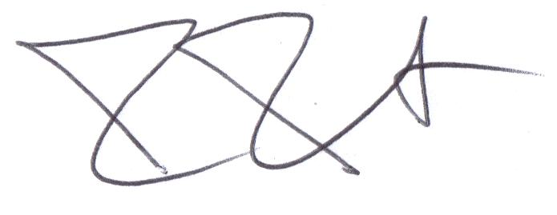

Dr Mel Mehmet MBE
Chief Executive
easitNETWORK

