Step by Step: How to set up and hold a conference call in Teams

Setting up the meeting
In the past, you may have used Skype for Business (SfB) for meetings by including a virtual link to your Outlook meeting invitations. You can do the same with Microsoft Teams!
- Open Outlook, click on your calendar, and the “New Teams Meeting” button at the top. (if the button is not there, please contact the Service Desk).
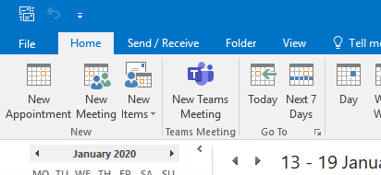

- This opens up a new meeting invite email. On this, you should have a “Join Microsoft Teams” link, and possibly a dial in number (see audio conferencing).
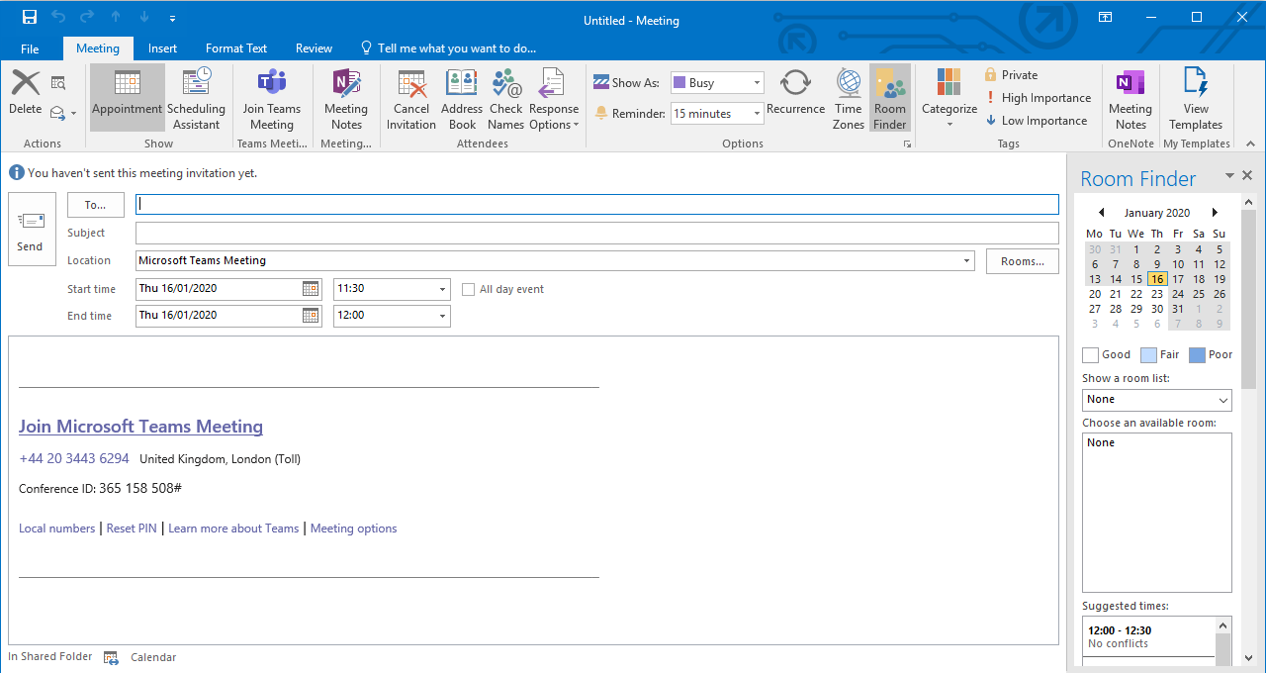
- Complete and send out.

Joining the meeting
At the time of the meeting, click the link in the meeting invite.
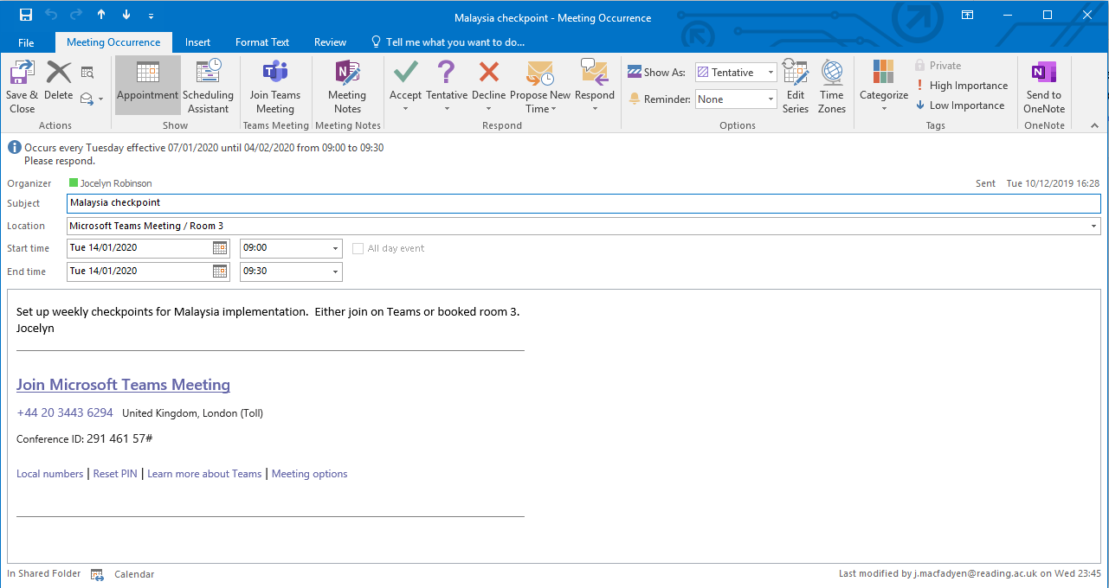
Clicking the link will open a browser window and give you the option of whether to open in your desktop app, download Teams, or stay in the browser.
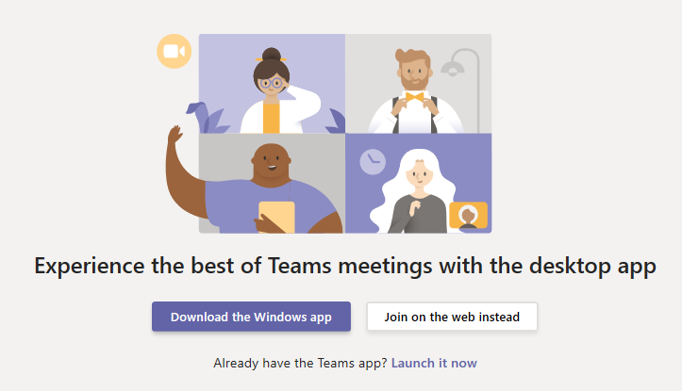
If you have Teams installed, you can choose to always open meetings in Teams so you don’t get the browser window starting (Chrome).
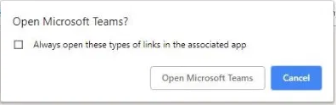

How to invite external attendees
You can invite external people to your meetings with Teams.

External Attendee 1: A user with any Office 365 Account (as a Guest User)
If the guests have Microsoft accounts, they can either use the web link as above or, if they click the ‘Open Microsoft Teams’ option and sign in to their Microsoft account, they can launch the Microsoft Teams client to get a richer user experience within the Teams meeting. This will include:
- Video/Camera options
- Desktop and File Sharing

External Attendee 2: A user with no Microsoft Account (any email address)
Anyone with an email address and device with an internet connection (e.g. laptop, tablet, smartphone) can access the call via the browser, by clicking on “Join Microsoft Teams Meeting” in the meeting invite, and then ‘Join on the web instead’ button:
There are some restrictions for an attendee on the web (they cannot share camera or screen), but they can view other attendees’ shared screens.

External Attendee 3: Anyone with a phone to dial in and join (audio conference)
You can also have a dial-in conference option so attendees can join the Microsoft Teams meeting from any device, anywhere. Users will automatically see the dial-in options for Microsoft Teams’ meetings, if the meeting organiser has this enabled.
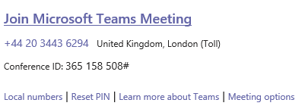

Set up meeting on behalf of someone else
If you want to set up a meeting on behalf of someone else, you need to do so from Outlook so it will appear “On behalf of”.
If you are organising a meeting for someone else, you may also want to change the settings for that meeting so that other people have the same privileges as the organizer. There are two roles to choose from: presenter and attendee. Presenters can do just about anything that needs doing in a meeting, while the role of an attendee is more controlled.
To get to settings for a meeting, select Meeting options on the invite:
This opens a new browser window with some options:
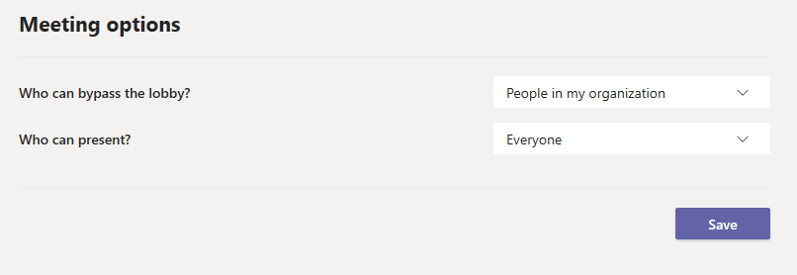

Who can bypass the lobby?
- Everyone
- People in my organisation and trusted organisations
- People in my organisation

Who can present?
- Everyone
- People in my organisation
- Specific people
- Only me
For more information on Roles in a Teams meeting go here: https://support.office.com/en-gb/article/roles-in-a-teams-meeting-c16fa7d0-1666-4dde-8686-0a0bfe16e019

