Name

Email address

School

Entry title

Excerpt (No more than 35 words)
This text will display on the ‘tile’ preview before readers click to read more.

Examples:
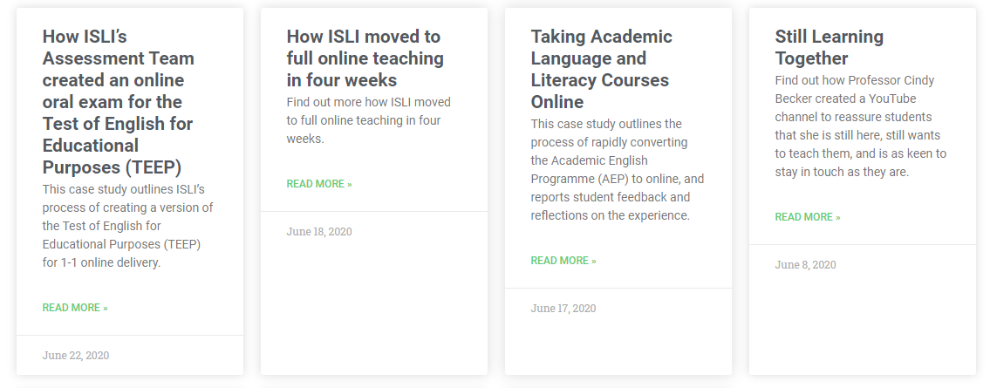

Overview (approx. 50 words)
Give a brief summary of the work undertaken and its impact.

Objectives (approx. 50 words)
Outline the aims of the activity in bullet point form.

Context (approx. 50 words)
Provide some information on why the activity was undertaken, including course or module details where relevant.

Implementation (approx. 150 words)
Outline the steps that were taken to carry out the activity.

Impact (approx. 100 words)
Provide some information about the outcomes of the activity: did it achieve its objectives? Were there any unexpected outcomes?

Reflections (approx. 150 words)
Consider what made the activity successful, and whether there were ways in which it could have been better implemented.

Follow up (approx. 50 words)
If some time has passed since the conclusion of the activity, give details of how the activity has developed or evolved.

Links
If there are any links that would support this entry, such as published articles about work undertaken or a project website, please provide them here.

If submitting a photograph or other image to illustrate your entry, please confirm in your email that you either own the copyright to the image and give permission for its use on the T&L Exchange, or that you have permission from the copyright holder for its use on the T&L Exchange.

Categories
Consider which of the following categories best describe the content of your entry and select no more than four.
Assessment and feedback
Curriculum design
Curriculum review
Diversity, inclusion and accessibility
Employability
Globalisation and internationalisation
PLanT projects
Research and enquiry
Student engagement
Student voice and partnership
Teaching and Learning Enhancement Projects (TLEP, formerly 'Mini' projects)
Technology enhanced learning

Tags
Consider if any relevant tags would help direct interest users to your entry- these can be more specific than Categories. Please type no more than four.

