EMA Submission Set-up Information Flow

Module Convenor to specify assessment | ⇒ | Programme Administrator to set-up submission points
 | Assessment Brief
 | ⇒
 | Module Description
 | ⇒
 | Mode of Submission Guidance
 | ⇒
 | Assessment Submission Details Form
 | ⇒
 | Assignment Set-up Information Spreadsheet
 | ⇒

The purpose of the documents Assessment Submission Details (1) and Assignment Set-up Information (2) is to assist with the flow of information from the module convenor to the programme administrator responsible for setting up the assignment.
They are designed for you to adjust to suit your school/department.

- Assessment Submission Details Form – Explained
The purpose of the Assessment Submission Details Form is twofold it aims to:
- Assist the Module Convenor to determine which mode of submission would best suit the specific assessment

- To provide the administrator with the information required to set up the submission point depending on mode of submission and feedback.

If you choose to use this form, send it to the module convenor who will provide some general information regarding the assessment:
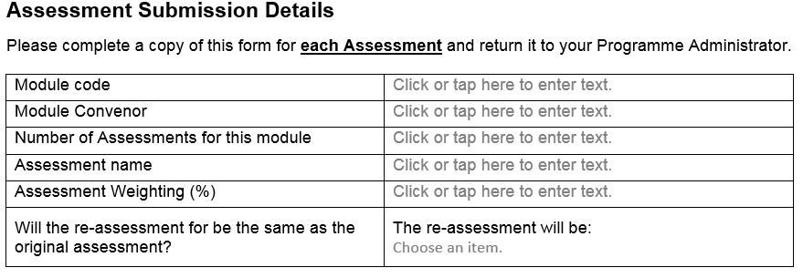

The next section asks the module convenor to select the type of submission the student will be making

Depending of the submission type selected they would then have three options
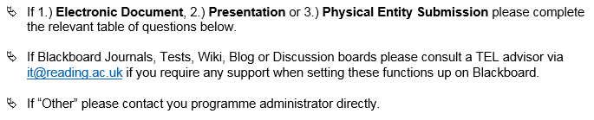

If the module convenor selects any of the submission types in the first bullet point, they need to answer the questions in the corresponding tables (the Electronic Document is show below as an example).
We have used these three options as they incorporate most scenarios and match the categories on the decision tree maps currently being developed to help academic staff to select the right mode of submission for their assessment.
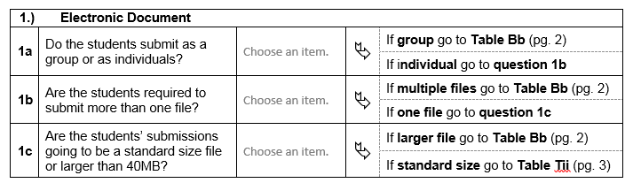

The questions direct the module convenor to complete, Table Bb (Blackboard) or Table Tii (Turnitin) which are on pages 2 and 3 of the same document.
These two tables Tii and Bb request all the information required for setting up the respective submission points. Every school/department can adapt the tables for their use.
Schools tend have some school/department wide preferences regarding how submission points are set up. You will be able replace the drop down box with the agreed preference or delete the row so the option does not appear.

For example, this section has the options:
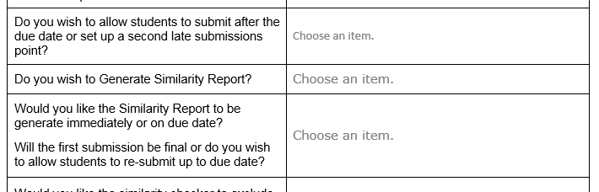
Change it to fixed responses: 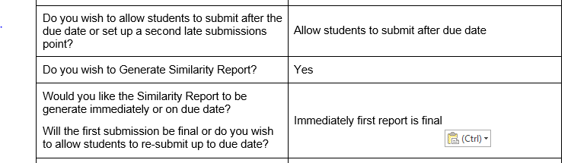
Alternatively delete the rows so that the question does not appear in the form at all.

- Assignment Set-up Information Spreadsheet Explained

The purpose of the Assignment Set-up Information spreadsheet is to help administrators to collate all the information required for setting up assignment drops.

With this spreadsheet, you can:
- Adjust it to comply with your school/department preferences:
  - There are tabs for both Turnitin and Blackboard Assignment tools. Each tab has a column directly relating to the set-up screen for each tool. Every school/department can adapt the forms for their use.

  - Schools have some school/department wide preferences regarding how submission points are set up. You will be able replace the drop down box with the agreed preference or delete the column so the option does not appear.

- Cut and paste information from the completed form
  - The columns in the spreadsheet correspond with the rows on the tables Tii and Bb. It is possible to copy the responses to the table and paste them into the spreadsheet.

  - Copy the responses you wish to move into the spreadsheet.

  - When pasting you will need to use the transpose paste in excel
  - 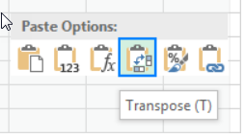

  - Unfortunately this option does not appear unless the selection is copied in excel. Paste into the blank tab and copy again once in excel.

  - The transpose paste option should now be available. It will transpose the column from the response form to a row in the spreadsheet.

- Use information from RISIS to populate the columns
  - The first tab “Assessment Details from RISIS” can be used to paste the Sub Modular Assessment Download form RISIS.

  - If you chose to do this particular cells in the Tii and Bb tabs will automatically populate with the information from RISIS.

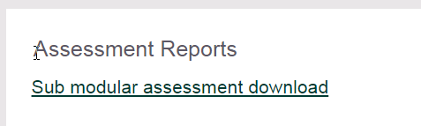
  - Go to RISIS – Working with Modules/Module Data and select Sub modular assessment download

  - Enter the relevant module code to call up your module details:

  - 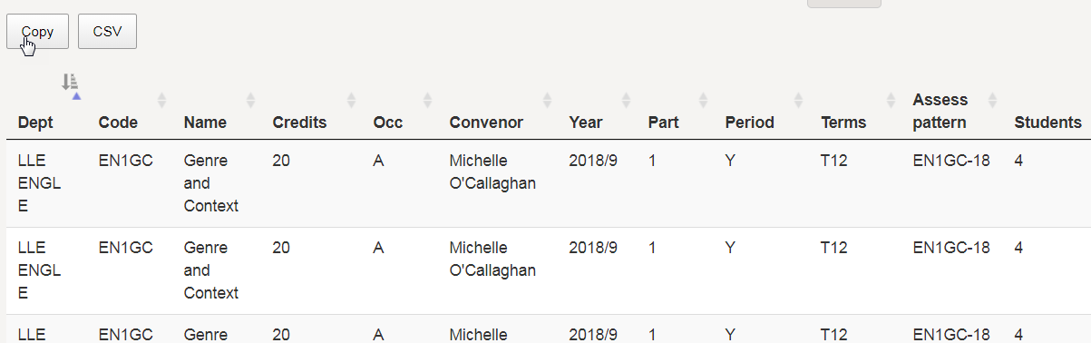

  - Use the copy button to copy the information shown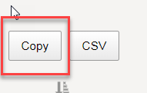

  - Open the first tab on the spreadsheet and paste into the top cell (1A)

  - 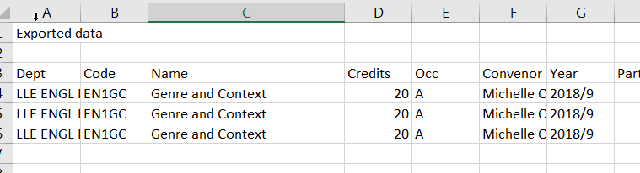

  - This will automatically populate some key information in the Tii and Bb tabs.

  - 