Blackboard Collaborate help guide for participants
Blackboard Collaborate is a web conferencing tool for online meetings, similar to Skype.
- Watch the Video overview to see what it looks like.

You will need…
- Internet-connected computer with sound (a microphone if you want to speak and a webcam if you want to be seen). We strongly recommend using a desktop/laptop for these webinars. For information on access using a mobile device, go to Bb Collaborate using a mobile device.

- We recommend using a headset or earbuds to avoid feedback noise.
- Use a wired internet connection, where possible. (Or a constant, strong Wi-Fi connection.)

Joining instructions
- Use the Google Chrome browser.
(Other browsers can be used but require Flash player. e.g. Firefox & Microsoft Edge.)

- Before joining the session:

- Connect any external headset, microphone or speakers before clicking the link.
- Check your audio and video works in Bb Collaborate well ahead of the session. (Click the webinar link and the first time you open it, you will be asked to check this.)
- Allow a few minutes before the start of the session to launch the webinar and login.
- Click the link to join the webinar.
INSERT LINK TO ROOM IF YOU ARE USING THE GUEST LINK
OR
- Log in to Blackboard & enter the course: ENTER COURSE NAME HERE
- In the course go to ENTER LOCATION OF LINK IN COURSE to launch the session.
- Follow the on screen instructions to get set up.
If you are not able to connect the first time, don’t worry! Please click the Reconnect button to try again.
DELETE ME AND INSERT SCREENSHOT OF WHERE TO FIND LINK TO SESSION IN THE COURSE

Access using a mobile device
We strongly recommend using a desktop for these webinars.
If you need to use your mobile device to join the session:
- Open the link provided in your mobile device.
- This will prompt you to download the ‘Bb Student app’.
- Once the app has installed, click on the link again.
- Follow any on-screen instructions on your device. The Bb Student App will launch and allow you to join the webinar.
- Type your name and Join as a Guest.
Further information on joining Bb Collaborate using a mobile device.
Note: You will need a reliable and strong Wi-Fi signal, (be aware of your mobile data allowance if you use a 3G or 4G connection) and make sure your device is fully charged.

Read the Feature Overview on the next page…

Features overview
On entering the room, you will see the following buttons. (Audio and/or Video may not show if the session moderator has not made them available).
You will either see a video / image of others who have joined the session or a slide presentation in the main window.
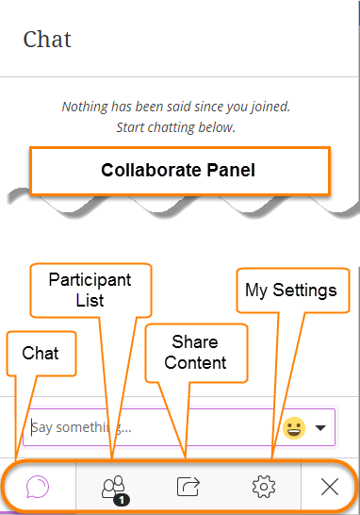
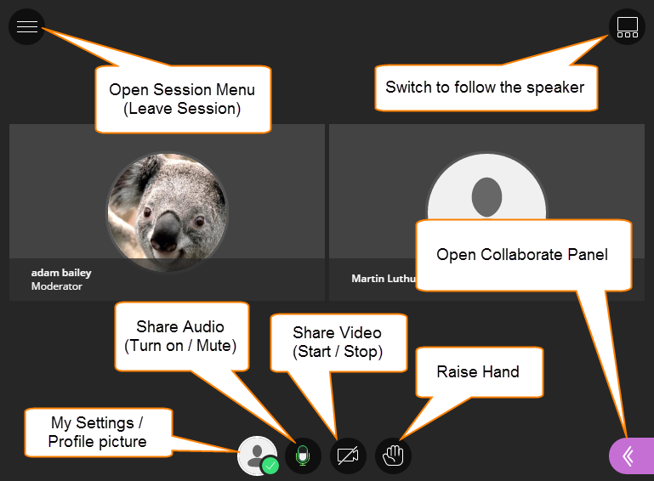
Top Tip: Mute Audio when you are not speaking to prevent feedback loop noise.
Click the Audio and Video buttons to enable them.
Raise Hand – Click to indicate you want to speak or have a question, when directed to.
Open the Collaborate Panel to see:
Chat – Post questions or comments to everyone in room. Use the emoticons to give feedback.
Participant List – See who else is in the session. Check the quality of your Network Connection by hovering your mouse over your name.
My Settings – Check your Audio and Video Settings, add a profile picture and set yourself as Present or Away.

